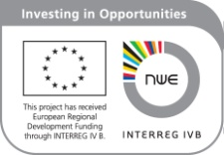

AMICE FINAL CONFERENCE
Bridging Gaps!
March 13-15 2013 - Sedan, FRANCE

Poster submission

Title
Subtitle
Author 1
Author 2
Abstract

Submit

